LACE UP AGAINST DRUGS
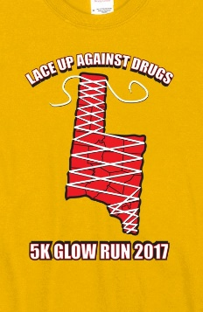
5KGlow Run
Saturday, April 22, 2017
Registration begins at 7:00 p.m.
Race Start Time 8:15 P.M.
Please join
Brown County Youth Drug Prevention Coalition
for our 1st Annual Glow Run

Start: Georgetown High School, 987 Mt. Orab Pike, Georgetown, Ohio 45121
Entry Fees 5K (Non-Refundable)
$15.00 Youth 5 -17
$25.00 Early registration (through April 7th)
$30.00 April 7th through Day of Race (Shirts cannot be guaranteed day of race)
Make checks payable to: RULH BPA
Mail the bottom of the registration form to: Ripley Union Lewis High School, Attn: Tammy Whaley, 1317 S. 2nd Street, Ripley, Ohio 45167
Check in & Registration: Race day registration 7:00 – 8:00 p.m. and same day registration

~~~~~~~~~~~~~~~~~~~~~~~~~~~~~~~~~~~~~~~~~~~~~~~~~~~~~~~~~~~~~~~~~~
Name: ___________________________________________________________________
Address: ________________________________ City, State, Zip____________________
E-mail: ____________________________________________________________________
Male: ____________ Female: ____________ Age: _________ Date: of Birth: _________
Phone Number: ________________________
T-Shirt shirt: YM –YL-AS-AM-AL-AXL-A2L (CIRCLE ONE) T-Shirt only___________$15.00
Emergency contact: (required)___________________________ Phone: ____________________
Waiver: all registrants are required to sign this waiver. In consideration of the acceptance of my entry, I hereby waive discharge and release on my behalf of my heirs, executors, and assigns, all claims of any nature, including but not limited to damages, actions, whatsoever in any manner arising from my participation at the Glow Run do hereby release the Brown County Youth Drug Prevention Coalition employees, trustees, sponsors, workers, officials and volunteers from any claim whatsoever arising from this event. I agree to abide all the rules of participation and acknowledge that the Brown County Youth Drug Prevention Coalition has the right to refuse or return my entry at its discretion. I attest and verify that I understand the risks involved in such a run/walk and that I am physically fit and have trained adequately in preparation. I give Brown County Drug Prevention Coalition to take my photograph during the event and use it in its publicity, media, and marketing material.
Signature: _________________________________________________________________ Date: __________________ (Parent signature if under 18 years of age)

